CREATE, CHANGE, OR DELETE SERVICE ENDPOINT POLICY

STEP-01 CREATING THE SERVICE ENDPOINT POLICY

PATH IS SEARCH SERVICE ENDPOINT POLICY 🡪 CREATE AND FOLLOW WIZARD AS SHOWN BELOW

NOTE: IF YOU DON’T ALREADY HAVE A RESOURCE GROUP OR RESOURCE (IN THIS LAB A STORAGE ACCOUNT CREATED) YOU CAN GO AHEAD CREATE THE POLICY.

AFTERWARDS, AND GETTING THOSE RESOURCES NEEDED YOU CAN EDIT THE POLICY BY GOING TO SERVICE ENDPOINT POLICY 🡪 POLICY DEFINITIONS AND ADD RESOURCE AS SHOW BELOW IN SECOND IMAGE

STEP-03 CREATING VNET WITH SUBNET

LIKE IN PREVIOUS LABS HERE IS MY CONFIGURED VNET.

IF YOU DON’T ALREADY HAVE A VNET MADE PATH IS GO TO SEARCH 🡪 VIRTUAL NETWORKS 🡪 CREATE

ON THE BASIC PAGE JUST SELECT/CREATE RESOURCE GROUP, NAME AND REGION

ON THE IP ADDRESS PAGE FILL IN WITH YOUR IPV4 RANGE AND CREATE YOUR SUBNETS. WHEN CREATING SUBNETS, YOU CAN GO AHEAD AND ADD YOUR SERVICE ENDPOINT SELECTION WITHIN CREATON

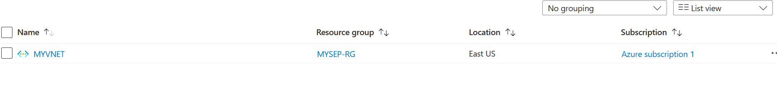

STEP-04 ASSOCIATE SERVICE ENDPOINT POLICY TO SUBNET

PATH GO TO SERVICE ENDPOINT POLICIES 🡪 ASSOCIATED SUBNETS 🡪 EDIT SUBNET ASSOCIATION🡪 SELECT YOUR VNET AND CHECK YOUR SUBNET AND ADD AS SHOWN BELOW

